TASK5:
#include <stdio.h>

int main() {
int A = 8;
int left_shift = A << 2;
int right_shift = A >> 1;

printf(" A = %d\n", A);
printf("A << 2 (Decimal) = %d\n", left_shift);
printf("A >> 1 (Decimal) = %d\n", right_shift);

return 0;
}
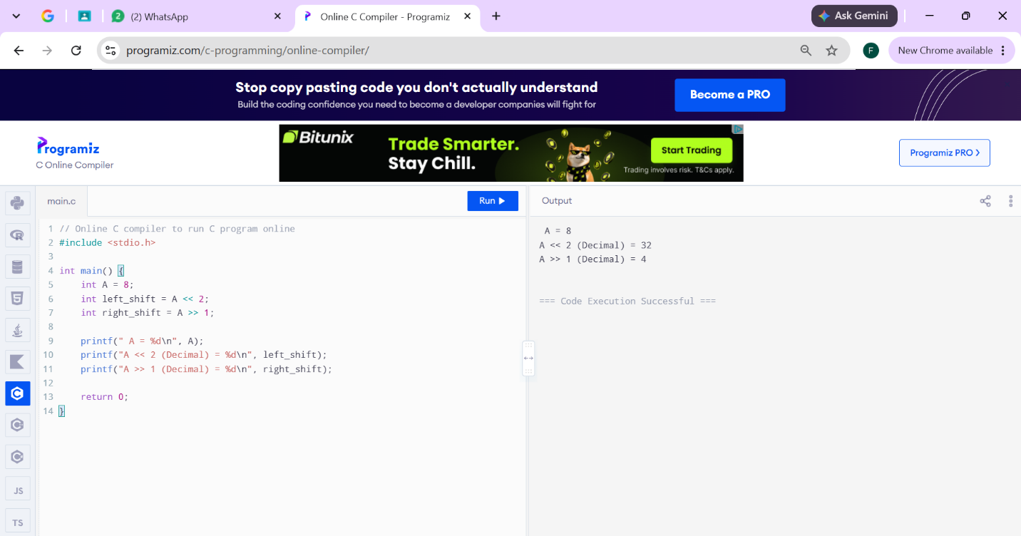
TASK1:
#include <stdio.h>

int main() {
int age, marks;
printf("Enter student's age: ");
scanf("%d", &age);
printf("Enter student's marks: ");
scanf("%d", &marks);
if (age >= 18) {
if (marks >= 50) {
printf("Eligible for Admission\n");
} else {
printf("Not eligible for admission");
}
} else {
printf("Not eligible for admission.\n");
}

return 0;
}
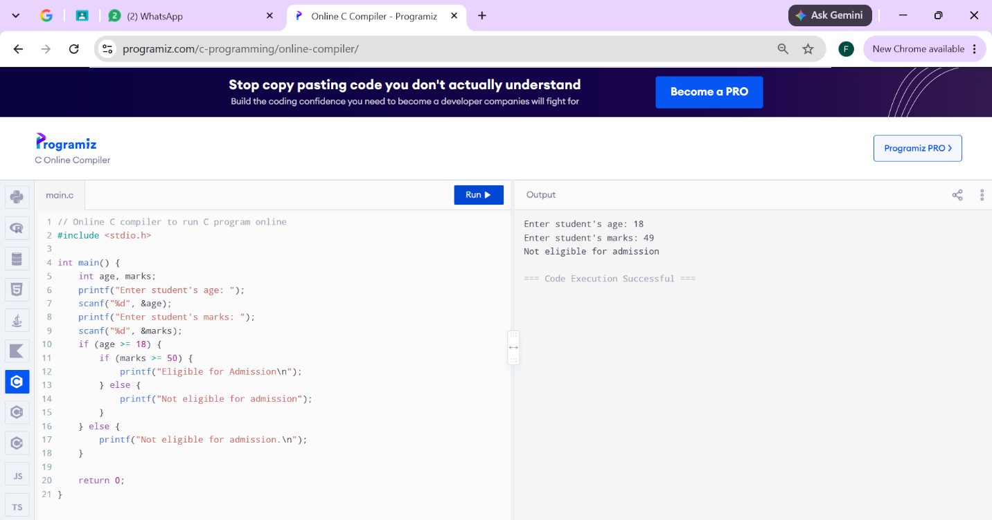
TASK4:
#include <stdio.h>

int main() {
int marks;
printf("Enter student's marks: ");
scanf("%d", &marks);
(marks >= 50) ? printf("Pass\n") : printf("Fail\n");

return 0;
}

